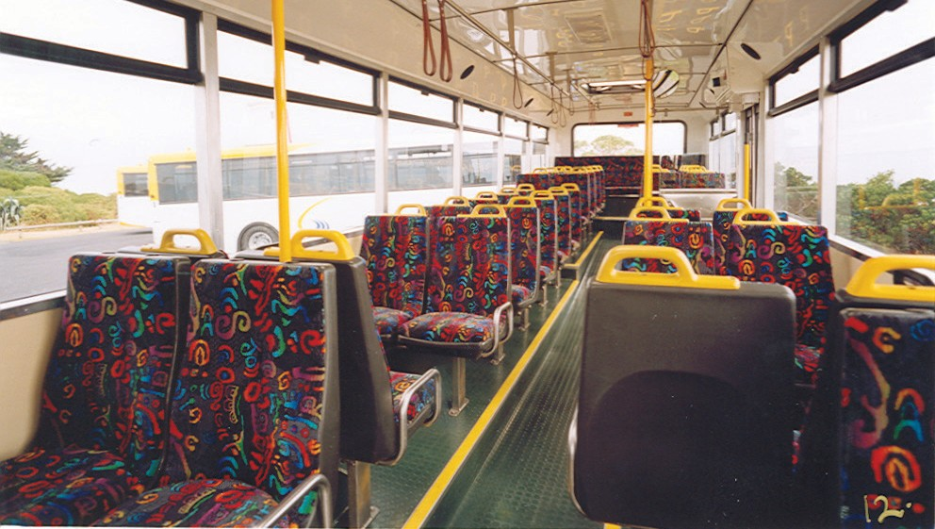
Insert your company name and or logo here
Passenger Transport Services
Operator Accreditation
Handbook – Part 2

January 2014

This page is intentionally blank

CONTENTS

APPOINTMENT OF RESPONSIBLE PERSON 1
ACCREDITATION CHECKLIST 2
NOTIFICATION OF CHANGE OF DETAILS 3
REGISTER OF VEHICLES 4
PRE-DEPARTURE INSPECTION PROCEDURE 5
PRE-DEPARTURE CHECKLIST 6
EMERGENCY INSTRUCTIONS - COLLISIONS 7
INCIDENT REPORT FORM – INCIDENTS OTHER THAN COLLISIONS 9
SCHOOL BUS INCIDENT REPORT FORM 10
DRIVER REGISTER 14
DRIVER MONITORING 15
PASSENGER BEHAVIOUR MANAGEMENT EXAMPLE POLICY
BEHAVIOUR GROUPS – PASSENGER TRANSPORT & REGULAR PASSENGER SERVICES 16
SAMPLE CODE OF CONDUCT FOR SCHOOL STUDENTS ON BUSES 21
PASSENGER BEHAVIOUR MANAGEMENT POLICY PROCEDURES
CATEGORY 1 – OFFENSIVE BEHAVIOUR BY A STUDENT 24
CATEGORY 2 – DANGEROUS AND/OR DESTRUCTIVE BEHAVIOUR BY A STUDENT 25
CATEGORY 3 – LIFE THREATENTING BEHAVIOUR BY A STUDENT 26
SAMPLE CODE OF CONDUCT FOR DRIVERS OF SCHOOL BUSES 27
BEHAVIOUR MANAGEMENT POLICY PROCEDURES - INAPPROPRIATE BEHAVIOUR BY A DRIVER 28
REPORTABLE INCIDENT MANAGEMENT PROCEDURES FOR PASSENGER TRANSPORT SERVICES 29
NOTIFICATION OF REPORTABLE INCIDENT 30

RESPONSIBLE PERSON Standard 1.1 Proforma 1.1

APPOINTMENT OF RESPONSIBLE PERSON

I, |  |  |  | agree to be the Responsible Person
 | Name of Responsible Person
for
 | Company/Partnership
and can be contacted on:
Phone |  | Email

I understand by responsibilities as the Responsible Person and acknowledge that I have read and understood the manual or procedures covering the modules for accreditation.

Signed |  | Date

Company Details:

Partnership, Business or Company Name
Business Address
 |  | Number Street
 |  | Suburb Postcode
Postal Address
 |  | Suburb Postcode
Email
Phone Contacts
 |  | Phone Mobile Fax
 | Yes | A National Police Certificate has been obtained and kept on file for our service’s Responsible Person.

Forward the completed form to: Passenger Transport Operator Accreditation
Vehicle Operations Branch
Department of Infrastructure Energy and Resources
PO Box 936
HOBART TAS 7001
RECORD KEEPING Standard 1.2 Proforma 1.2

RECORD KEEPING – ACCREDITATION CHECKLIST

 | Standard Reference | Document
 |  | Accreditation Certificate issued by the Transport Commission
 |  | National Police Certificate for your service’s Responsible Person
 |  | Passenger Transport Services Operator Accreditation Manual
 | 1.4 | List or register of all the vehicles that you use to operate your service Registration documents for all vehicles
 | 2.1 | All roadworthiness inspection reports for each vehicle
 | 2.2 | All completed pre-departure inspection checklists for each vehicle
 | 2.3 | All fault reports for each vehicle  Records of repairs undertaken as a result of faults identified
 | 2.4 | Records of major vehicle safety inspections
 | 2.5 | Emergency management procedures
 | 3.2 | Driver register, including driver acknowledgement of awareness of:  - Pre-departure inspection procedures (Standard 2.2)  - Fault reporting system (Standard 2.3)  - Emergency management procedures (Standard 2.5)  - Passenger behaviour management procedures (Standard 3.4)  - Reportable incident management procedures (Standard 3.5)
 | 3.2 | Driver file or other filing method to keep documents relevant to each driver’s  engagement or employment
 | 3.3 | Record of having checked the details held in your driver register for each driver to ensure that each driver still holds a current driver licence and Ancillary Certificate
 | 3.4 | Passenger behaviour management procedures
 | 3.5 | Reportable incident management procedures

MAINTAINING ACCREDITATION DETAILS Standard 1.3 Proforma 1.3

NOTIFICATION OF CHANGE OF DETAILS

From:
Partnership/Business/Company Name
Address:
Suburb |  | Postcode
The following changes have been made to the accreditation details previously supplied.
NEW DETAILS
Responsible Officer |  | Name
 |  | Phone Email
Partnership, Business or Company Name
Business Addresses |  | Number Street
 |  | Suburb Postcode
Postal Addresses
 |  | Suburb Postcode
Email
Phone Contacts |  | Phone Mobile Fax
Type of public passenger service provided
Size of the vehicle(s) being used to operate the passenger transport service
Other relevant information
Completed By | Responsible Officer |  | Date

Forward the completed form to: Passenger Transport Operator Accreditation
Vehicle Operations Branch
Department of Infrastructure Energy and Resources
PO Box 936
HOBART TAS 7001

VEHICLE REGISTRATION Standard 1.4 Proforma 1.4

REGISTER OF VEHICLES

Note: This form must be kept up to date. The fleet register needs to be reviewed at least annually as a part of any accreditation audit. It also needs to be updated whenever another vehicle is brought into the business - whether via purchase/lease, or via short term hire or sub contract arrangement.

Company/Partnership: |  | Date:

Vehicle No/  Fleet No/ Identifier  (optional) | Registration  Number | Registration Expiry date  dd/mm/yy | Manufacture Date  mm/yy | Date of Purchase  dd/mm/yy | Vehicle  Make/Model | Operational Capacity  Seated Standing |  | MAIB Premium  Class | First Inspection Due  dd/mm/yy | Second Inspection Due  (if applicable) | Date Due for Replacement  dd/mm/yy

DAILY INSPECTION SHEET Standard 2.2 Proforma 2.2A

PRE-DEPARTURE INSPECTION PROCEDURE

 |  | Before the first trip each day, the driver (or nominated employee) will carry out the inspection procedure as listed on your Pre-Departure/Daily Inspection Check List. A copy of the checklist to be completed (refer to diagram 1) will be in the logbook required to be located in each vehicle.
Yes  (but with  minor defect) |  |  | Is the bus OK for service? |  |  |  |  | No
If a defect is found, the driver (or nominated employee) completes a Defective Vehicle Report (DVR). |  |  |  |  |  | If driver (or nominated employee) discovers a defect they believe renders the vehicle unsafe to operate, they will immediately contact their supervisor for instructions.
The Defective Vehicle Report (DVR) is to be completed and submitted as soon as practicable, but not later than the end of the shift after the discovery of the defect. |  |  |  |  |  | If a defect is found, the driver (or nominated employee) will complete a Defective Vehicle Report (DVR).
Yes
(without defect)
The driver completes the inspection and signs the Inspection Sheet to indicate the bus is okay for service.

DAILY INSPECTION SHEET Standard 2.2 Proforma 2.2B

PRE-DEPARTURE CHECKLIST

Person Conducting Test: | Name |  |  | Vehicle Registration:
Date:
 |  | = OK X = Defective
Interior check
- Check no unexpected or suspicious items located
- Seatbelts are serviceable and accessible to all passengers
Lights and reflectors
- Check all lights (headlights, front park/side lights, tail lights, brake lights, reversing lights, turn signal indicator lights, number plate light) for working order
Regulation signs and labels
- Inspection label, licence number plate (if required), and no-smoking sign are affixed and clearly visible
- Check vehicle is currently registered
Mirrors, windows and windscreens
- Check mirrors are securely mounted
- Windscreens, windows and mirror surfaces are clean and checked for damage
Wheels, tyres and rims
- Tyre pressure and tread integrity
- Wheels, rims and retaining rims
- Wheel security (loose or missing wheel nuts)
Horns and signals
- Horn is in working order
- Audible reversing signal (if applicable)
Wipers and washers
- Wipers are in working order and do not obstruct driver’s forward vision
- Windscreen washers have sufficient fluid
Oils/fuel/water
- Check levels
- Ensure no leaks of oil, fuel, water, refrigerant/coolant, hydraulic fluid or brake fluid
Structure and bodywork
- All panels and readily visible, structural members are secure
Brakes
- Brake failure indicators are in working order
- Check brake application whilst moving prior to departure
If defect found, complete DVR, and record number |  | DVR No. | DVR No. | DVR No. | DVR No. | DVR No. | DVR No. | DVR No.
Has DVR been lodged? (Y or N)
Is bus OK for service? (Y or N)
Refuel bus/coach
Litres
Kilometres
Wash bus (as time permits)
Initials of Person undertaking check,
on completion of check:
Comments:
EMERGENCY MANAGEMENT PROCEDURES Standard 2.5 Proforma 2.5A

EMERGENCY INSTRUCTIONS - COLLISIONS

Your first priority is to your passengers.

Resist the impulse to get straight out of your seat and argue with the other party about whose fault it was. Check your passengers. The other party will still be there in a minute or two.

What to do:

- DO NOT ADMIT LIABILITY

- If passengers (or anybody else) are injured, seek appropriate help immediately.

- If an ambulance is called you must wait for the Police to arrive.

- Under no circumstances should you talk to anybody about the accident or make any admissions with respect to liability.

- Contact your depot to report on the incident, state of the vehicle and passengers, and to arrange for alternative transport if the vehicle cannot be driven.

- Most collisions are relatively minor, with only slight damage ... so why bother arguing about who was at fault?

- Obtain the required information from the other party, keep calm, and get your passengers on their way.

- If the vehicle cannot be driven advise the passengers of alternative arrangements

- Clear the road of any debris, etc.

- Check all vehicle systems before continuing on the journey.

- Submit an Incident Report Form and complete any other forms at the depot at the end of the shift.

Information from the Scene

Injured Persons
- Full name and address
- Note their injuries
- Approximate age
- If they were on or off the bus

Other Party
- Full name and address
- Driver Licence details
- Date of birth
- Note any distinguishing features, ie, a beard or their hair colour, or if they were intoxicated or aged, etc.

EMERGENCY MANAGEMENT PROCEDURES Standard 2.5 Proforma 2.5A

EMERGENCY INSTRUCTIONS - COLLISIONS

Property involved
- Registered owner
- Full name and address
- Insurance company
- Extent of damage
- Condition of property, ie, old/new damage, etc.

Witnesses - at least TWO are required (if possible)
- Full names and addresses
- If they were on or off the bus
- If there aren’t any witnesses, obtain details from two passengers.

Police
- Name and/or badge number of officer, and their Station
- Who has been charged?
- Are charges pending?

Before leaving the scene
Make a drawing showing the following:
- Street names/exact location
- Distances from curb/intersection, etc.
- Point of impact
- Directions in which vehicles were travelling
- Lane markings/object at the scene

Do not leave the scene until these details have been completed. Do not rely on your memory.

At the Depot
- Advise supervisor immediately on return
- Complete company report sheet
- Do not leave until report sheet is completed.

EMERGENCY MANAGEMENT Standard 2.5 Proforma 2.5B

INCIDENT REPORT FORM – INCIDENTS OTHER THAN COLLISIONS

Day |  |  |  |  | Date |  |  |  |  |  |  |  |  | Time
 | Passenger/Public Injury |  |  |  |  | Employee Lost Time/Injury |  |  |  |  |  |  |  |  |  | Vandalism/Projectiles
 | Medical Incident |  |  |  |  | Violence/Offensive Behaviour |  |  |  |  |  |  |  |  |  | Other
Location
of Incident
Describe the incident
Indicate the apparent cause of the incident
Was the incident reported to Police? If so, who was reported?
Name |  |  | Given Names Surname
Address |  |  | No. Street Suburb Postcode
Date of Birth |  |  |  |  |  |  |  | Or age |  |  |  |  |  |  |  |  |  | Gender
Officer’s Name |  |  | Given Names Surname |  |  |  |  |  |  |  |  |  |  |  |  |  |  | Station/ Badge No.
Did an injury occur? If so, who was injured?
Name |  |  | Given Names Surname
Address |  |  | No. Street Suburb Postcode
Date of Birth |  |  |  |  |  |  |  | Or age |  |  |  |  |  |  |  |  |  | Gender
Bus/Coach/Machinery/make, type and model
Were all guards in place? |  |  |  |  |  |  |  |  |  |  |  |  |  |  |  |  | YES |  |  |  |  |  | NO
Were all safety precautions followed? |  |  |  |  |  |  |  |  |  |  |  |  |  |  |  |  | YES |  |  |  |  |  | NO
Was the operator trained (via induction) in this activity? |  |  |  |  |  |  |  |  |  |  |  |  |  |  |  |  | YES |  |  |  |  |  | NO
If not, why not?
Information completed by |  |  | Name |  |  |  |  |  |  |  |  |  |  |  |  |  |  |  | Time
 |  |  | Signature |  |  |  |  |  |  |  |  |  |  |  |  |  |  |  | Date
Employment details |  |  | (Capacity/Title/Role)

EMERGENCY MANAGEMENT Standard 2.5

SCHOOL BUS INCIDENT REPORT FORM

Access the form shown on pages 11, 12 and 13 via the following link:
http://www.transport.tas.gov.au/pdf/passenger_forms/PTS035-1F_School_Bus_Incident_Report.pdf

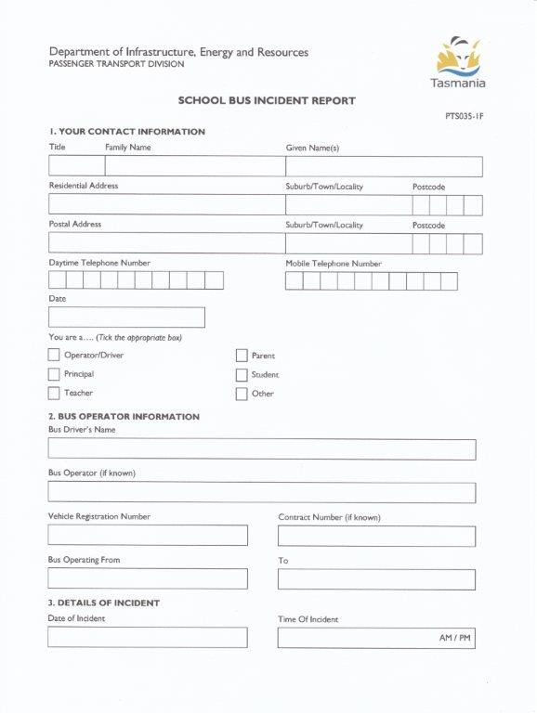
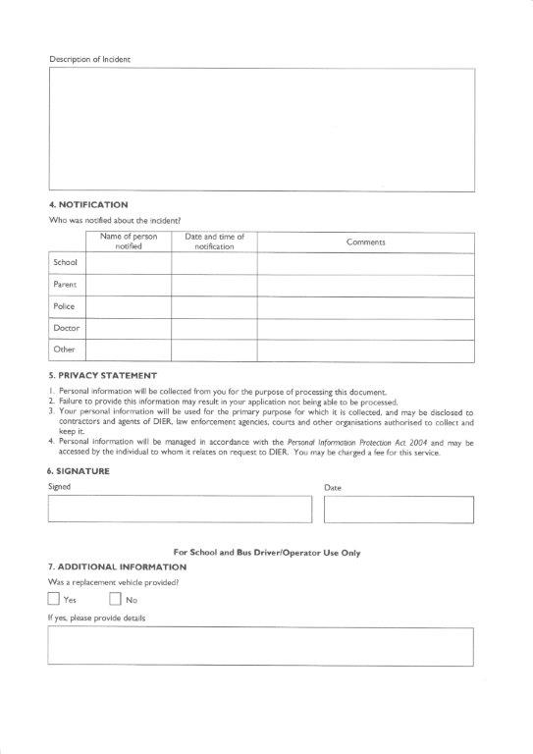
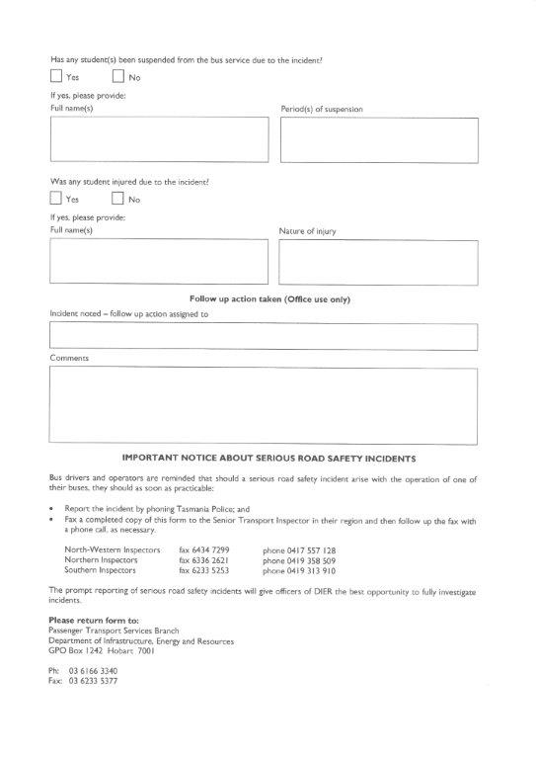

DRIVER RECORDS Standard 3.2 Proforma 3.2

DRIVER REGISTER

Full Name of Driver |  |  |  |  |  |  |  | Employment  Start Date
Address of Driver | Number Street |  |  |  |  |  |  | Home Ph
 | Suburb Postcode |  |  |  |  |  |  | Mobile
Driver’s Licence | Number |  |  |  | Class |  |  | Expiry Date
Driver’s Ancillary | Type |  |  | Taxi |  | Passenger Transport |  | Expiry Date
Checked By | Name Signature Date
HOW WAS THE DRIVER MADE AWARE OF THEIR REQUIREMENTS?
Awareness Requirements | Discussion | Memo | Printed Materials |  | Training Program | Combination | Date | Employee Signature# |  | Employer Signature#
Pre-Departure Inspection *
Reportable Incidents *
Mechanical Faults/ *
Defects Report
Emergency Procedures *
Passenger Behaviour (adults) *
Passenger Behaviour (students)
Health and Safety Policy
Conditions of Employment
* Mandatory
Drivers are to sign this register to indicate that they have read and understood the procedures and policies that describe their duties and agree that they will carry out their duties in the manner described in the manual. Photocopies of Driver Licence, Driver Ancillary Certificate and other Endorsements (if applicable) should be attached. # By signing this form you agree that you are aware of/have read and understood your duties and obligations and the procedures to be followed.

DRIVER MONITORING Standard 3.3 Proforma 3.3

DRIVER MONITORING

Driver’s name
Driver’s licence number, class  and expiry date (day/month/year) |  | Current? | Yes  No
Driver’s Ancillary Certificate  expiry date  (day/month/year) |  | Current? | Yes  No
Checked by | (Name and signature) | Date
Driver’s licence number,  Class and expiry date (day/month/year) |  | Current? | Yes  No
Driver’s Ancillary Certificate  expiry date  (day/month/year) |  | Current? | Yes  No
Checked by | (Name and signature) | Date
Driver’s licence number, class  and expiry date (day/month/year) |  | Current? | Yes  No
Driver’s Ancillary Certificate  expiry date  (day/month/year) |  | Current? | Yes  No
Checked by | (Name and signature) | Date

PASSENGER BEHAVIOUR MANAGEMENT Standard 3.4 Proforma 3.4A

PASSENGER BEHAVIOUR MANAGEMENT EXAMPLE POLICY

BEHAVIOUR GROUPS – PASSENGER TRANSPORT & REGULAR PASSENGER SERVICES

Group 1 – Nuisance and Offensive Behaviour (little or no risk of physical danger to an individual or damage to the vehicle)

Passenger Transport Services
- Behaving in an offensive or indecent manner (regulation 16(1)(f)).
- Using profane, indecent, obscene, offensive or blasphemous language (regulation 16(1)(g)).
- Behaviour that is prohibited by the service’s conditions of travel (regulation 11).

Regular Passenger Services
- Littering in the vehicle (regulation 16(2)(d)).
- Placing feet on the seats of the vehicle (regulation 16(2)(f)).
- Spitting on the vehicle (regulation 16(2)(g)).
- Playing an instrument (regulation 16(2)(h)).
- Busking (regulation 16(2)(i)).
- Eating or drinking a substance other than water, unless this is necessary for medical reasons (regulation 16(5)(a)).
- Occupying more than one seat (regulation 16(5)(b)).
- Selling or distributing anything, or attempting to do so (regulation 16(5)(c)).
- Displaying a sign, or attempting to do so (regulation 16(5)(d)).
- Affixing something to the vehicle or attempting to do so (regulation 16(5)(e)).

Group 2 – Dangerous Behaviour (some risk of physical danger to an individual or damage to the vehicle)

Passenger Transport Services
- Doing something to endanger the safety of passengers, the driver or the vehicle (regulation 16(1)(a)).
- you would need to determine the types of behaviour that would fit into this category (e.g. distracting the driver, holding their own arms out the window, pressing stop buttons repeatedly etc).
- Threatening, harassing or attempting to intimidate another person (regulation 16(1)(b)).
- Wilfully disturbing the comfort or convenience of another person (regulation 16(1)(d)).
- Soiling, damaging or defacing another person’s property (regulation 16(1)(e)).
- Throwing things from the vehicle (regulation 16(1)(h)).

Regular Passenger Services
- Possessing an open container of alcohol (regulation 16(2)(c)).
- Having an animal on board the vehicle, other than an animal permitted by law (regulation 16(2)(e)).
- Failing to vacate seat for a person with a disability or injury, an elderly person, a visibly pregnant woman, a person accompanying a child less than 5 years of age or other person who appears to have special needs (regulation 16(3)).

PASSENGER BEHAVIOUR MANAGEMENT Standard 3.4 Proforma 3.4A

PASSENGER BEHAVIOUR MANAGEMENT EXAMPLE POLICY

BEHAVIOUR GROUPS – PASSENGER TRANSPORT & REGULAR PASSENGER SERVICES

Group 3 – Very Destructive or Dangerous Behaviour (high risk of physical danger to an individual or damage to the vehicle)

Passenger Transport Services

- Doing something to endanger the safety of passengers, the driver or the vehicle (regulation 16(1)(a))
- you would need to determine the types of behaviour that would fit into this category (e.g. fighting etc).

- Wilfully obstructing or hindering another person (regulation 16(1)(c)) – e.g. preventing someone from getting off the bus.

- Soiling damaging or defacing the vehicle (regulation 16(1)(e))
- you would need to determine the types of behaviour that would fit into this category (e.g. breaking windows, slashing seats etc).

Regular Passenger Services

- Smoking (regulation 16(2)(a)).

- Drinking alcohol (regulation 16(2)(b)).

Group 4 – Highly Dangerous or Potentially Life-Threatening Behaviour (extreme risk of serious physical danger to an individual)

- Doing something to endanger the safety of passengers, the driver or the vehicle (regulation 16(1)(a))
- you would need to determine the types of behaviour that would fit into this category (e.g. physically attacking the driver or another passenger, spitting at a person, lighting a fire, threatening harm with a dangerous weapon etc).

- Soiling damaging or defacing the vehicle (regulation 16(1)(e))
- you would need to determine the types of behaviour that would fit into this category (e.g. lighting a fire, interfering with the mechanical operation of the vehicle etc).

PASSENGER BEHAVIOUR MANAGEMENT Standard 3.4 Proforma 3.4A

PASSENGER BEHAVIOUR MANAGEMENT EXAMPLE POLICY

MANAGEMENT PROCEDURES – PASSENGER TRANSPORT & REGULAR PASSENGER SERVICES

Group 1 – Nuisance and Offensive Behaviour (little or no risk of physical danger to an individual or damage to the vehicle)

First Incident |  | - Driver advises passenger that behaviour is inappropriate & reminds passenger of consequences of repeated offences.
No further incident |  | - No further action.
Repeated Incident |  | - Driver again advises passenger that behaviour is inappropriate & reminds passenger of consequences of repeated offences.  - Driver notes passenger’s name (as permitted by Regulation 15), records incident and action taken.  - Driver provides operator with a copy of incident report.

Group 2 – Dangerous Behaviour (some risk of physical danger to an individual or damage to the vehicle)

First Incident |  | - Driver issues caution & and advises passenger of consequences of repeated offences. Driver notes passenger’s name (as permitted by Regulation 15), records incident and action taken.
No further incident |  | - No further action. Driver provides operator with a copy of incident report.
Repeated Incident |  | - Driver issues further caution.  - If no further incident, at completion of the journey driver advises passenger that travel would be refused on the next journey with the company.  - Driver records incident and provides operator with a copy of incident report.
2nd Repeated Incident |  | - Driver advises passenger that they will be dropped off at the nearest practical point along the bus route.  - Driver offers to call a person nominated by the passenger to collect the passenger.  - Driver notifies Tasmania Police Communications Centre* of incident details.  - Driver records incident and provides operator with a copy of incident report.

PASSENGER BEHAVIOUR MANAGEMENT Standard 3.4 Proforma 3.4A

PASSENGER BEHAVIOUR MANAGEMENT EXAMPLE POLICY

MANAGEMENT PROCEDURES – PASSENGER TRANSPORT & REGULAR PASSENGER SERVICES

Group 3 – Very Destructive or Dangerous Behaviour (high risk of physical danger to an individual or damage to the vehicle)

First Incident |  | - Driver issues caution and advises passenger of consequences of repeated offences. Driver notes passenger’s name (as permitted by Regulation 15), records incident and action taken.
No further incident |  | - No further action. Driver provides operator with a copy of incident report.
Repeated Incident |  | - Driver advises passenger that they will be dropped off at the nearest practical point along the bus route.  - Driver offers to call a person nominated by the passenger to collect the passenger.  - Driver notifies Tasmania Police Communications Centre* of incident details  - Driver records incident and provides operator with a copy of incident report.

Group 4 – Highly Dangerous or Potentially Life-Threatening Behaviour (extreme risk of serious physical danger to an individual)

First Incident |  | - Driver notes passenger’s name (as permitted by Regulation 15), records incident and action take.  - Driver advises passenger that they will be dropped off at the nearest practical point along the bus route.  - If situation is imminently dangerous** the passenger should be dropped off immediately and police informed of the whereabouts of the passenger.  - Driver notifies Tasmania Police Communications Centre* of incident details.  - Driver records incident and provides operators with a copy of incident report.

PASSENGER BEHAVIOUR MANAGEMENT Standard 3.4 Proforma 3.4A

PASSENGER BEHAVIOUR MANAGEMENT EXAMPLE POLICY

MANAGEMENT PROCEDURES – PASSENGER TRANSPORT & REGULAR PASSENGER SERVICES

NOTE:

* If at any stage the driver believes that Tasmania Police should become involved and an arrest or charges made, the driver should contact the Police Communications Centre and arrange for Police Officers to board the bus somewhere along the bus route. Contact 000 for emergencies or 131 444 for non-emergency situations.

Police have more powers of arrest if they attend the scene of a crime and a person is found to be offending or is in circumstances that lead a Police Officer to believe that they have offended.

** You may also wish to include information for drivers relating to actions they might take to restrain or prevent a potential offender from committing a highly dangerous or life threatening behaviour. Under these circumstances, Section 39 of the Criminal Code outlines the rights of drivers and others in such matters.

It is lawful for any person to use such force as he believes on reasonable grounds to be necessary in order to prevent the commission of a crime, the commission of which would be likely to cause immediate and serious injury to any person or property, or in order to prevent any act being done which he believes on reasonable grounds would, if done, amount to any such crime.

PASSENGER BEHAVIOUR MANAGEMENT Standard 3.4 Proforma 3.4B

SAMPLE CODE OF CONDUCT FOR SCHOOL STUDENTS ON BUSES

When travelling between home and school, students must adhere to various regulations regarding passenger behaviour and the codes of conduct for travel by bus and or rail. It is every student's responsibility to behave in a manner that ensures the safety and comfort of passengers and drivers. This includes:

Behaving appropriately
- Behave safely at all times.
- Respect the needs and comfort of other passengers, such as no use of offensive or racist language, fighting, spitting, placing feet on seats, throwing things in or from the bus, eating or drinking - except water - unless the bus operator gives permission.
- Keep arms, legs and other parts of their bodies inside the bus.
- Protect all property and report any vandalism.
- Follow instructions about safety.
- Obey reasonable directions from the driver, such as where to sit or to remain in the bus.
- Adhere to the law that bans smoking.
- Give up seats to all adults and disabled passengers.
- Refrain from attracting the attention of the driver except in the case of emergency.

Respecting property
- Protect bus property.
- Ensure that buses are not vandalised.
- Report any vandalism, such as graffiti and window etching.

If students misbehave on buses (for example):

Unacceptable behaviour such as using offensive or racist language, disobeying reasonable directions from the driver, smoking, spitting, damaging property, eating on the bus, distracting the driver with persistent noise, or
Dangerous behaviour such as seriously bullying or harassing other passengers, fighting, letting any part of your body protrude from the bus, throwing objects inside or outside the bus, using matches and lighters, carrying dangerous items and group misbehaviour, or
Highly dangerous behaviour such as interfering with safety equipment, pushing students out of the doors or windows, assaulting the driver or other passengers and destruction of bus property

Such behaviour may lead to:
- Loss school travel privileges.
- Permanent suspension of school bus travel privileges, or being banned from travelling on buses may apply for repeated offences.
- Being banned from travelling on buses.
The police will be called to deal with highly dangerous behaviour.
PASSENGER BEHAVIOUR MANAGEMENT Standard 3.4 Proforma 3.4B

SAMPLE CODE OF CONDUCT FOR SCHOOL STUDENTS ON BUSES

A group of school students behaving unacceptably may risk higher penalties if their conduct puts the safety of other passengers or the driver at risk.
Consequences of Inappropriate Behaviour
If a student misbehaves on a bus, the bus operator concerned will contact the parents and the school.
- Depending on the gravity of the offence, students may be refused travel on the bus for a period of time determined by the bus operator.
- Heavier penalties may apply to students involved in group misbehaviour.
- School principals have the right to take additional disciplinary action against a student under the school's discipline code or student welfare policy for any breach of the code of conduct.
The bus operator must provide written notification to the parents, guardians or carers before a student's school bus travel privileges can be withdrawn.
What to do if you disagree
If parents, guardians or carers don't agree with a decision, they should contact the bus operator. If they are still not satisfied, they can contact the DIER.

Categories of Inappropriate Behaviour
To promote consistency and fairness in responding to breaches of the Code of Conduct, inappropriate behaviour has been divided into three categories.

Category 1 – Unacceptable behaviour

This category includes minor offences, but is not limited to behaviour that may be irritating or unpleasant. Examples include:

- distracting the driver by persistent noise or calling out to the driver
- eating or drinking (other than water) on the bus, unless for medical reasons or with the permission of the bus operator
- smoking
- spitting
- using offensive or racist language
- minor bullying, intimidation and harassment of other passengers
- pressing the stop button continually
- damaging property
- window etching
- behaving so as to adversely affect the comfort or safety of other passengers (e.g. not giving up seats to any adults and disabled passengers).

PASSENGER BEHAVIOUR MANAGEMENT Standard 3.4 Proforma 3.4B

SAMPLE CODE OF CONDUCT FOR SCHOOL STUDENTS ON BUSES

Category 2 – Dangerous behaviour

This category includes more serious offences, but is not limited to behaviour that may cause an element of danger to individuals. Examples include:

- serious bullying and harassment of other passengers.
- allowing any part of their body to protrude from the bus while the bus is in motion.
- stopping others from disembarking at their stop.
- verbally threatening the driver.
- standing on steps or in areas not set aside for standing and refusing to sit down.
- pushing and shoving when boarding or exiting the bus.
- swinging on bus handrails.
- throwing things inside or out of the bus.
- fighting with other passengers.
- causing significant damage to property in buses.
- using matches/lighters.
- carrying dangerous items.
- group misbehaviour.

Category 3 – Highly dangerous or life threatening behaviour

This category includes major offences, but is not limited to highly dangerous behaviour. Examples include:

- pushing students out of the doors or windows.
- interfering with the driving controls or the emergency door release.
- assaulting the driver or other passengers.
- interfering with safety equipment.
- recklessly or negligently endangering the safety of other passengers or themselves.
- destruction of bus property.

If appropriate, the bus driver should report any incident involving highly dangerous or life threatening behaviour to the police.

The list of examples above is not intended to be exhaustive, but should be used as a guide in relation to management of behaviour on buses.

PASSENGER BEHAVIOUR MANAGEMENT Standard 3.4 Proforma 3.4B

PASSENGER BEHAVIOUR MANAGEMENT POLICY PROCEDURES

CATEGORY 1 – OFFENSIVE BEHAVIOUR BY A STUDENT

Offensive behaviour by a student involves distracting the driver, annoying or irritating other passengers, littering or otherwise increasing the task of cleaning the interior of the vehicle, or otherwise reducing the amenity of the trip. This includes issues of teasing, verbal bullying, victimisation, inappropriate language, courtesy and politeness, refusal to obey an instruction, or failure to observe any vehicle specific rules (such as occupancy of specific seats) as may be included in site specific locally defined codes of behaviour.

First Incident |  |  |  |  |  |  |  |  |  |  |  | - Where there may be some offensive behaviour by a student
Bus Driver |  |  |  |  |  |  |  |  |  |  |  | - Verbal warning. One or more verbal warnings may be given at the discretion of the driver. Warnings should be specific.
Bus Driver/Operator |  |  |  |  |  |  |  |  |  |  |  | - Written warning issued at conclusion of trip before student leaves bus.  - Record student’s name, date and details of incident.  - Copy to student, school, parent/guardian, operator records.  - Reminds student of consequences of repeated offences.  - Minor disciplinary action (student required to sit in designated seat.
No further incidents |  |  |  |  | Repeated incident  within 4 school weeks
No further action |  |  |  |  |  | Bus Driver / Operator |  |  |  |  |  | - Written warning.  - Record student’s name, date and details of incident.  - Copy to student, school, parent/guardian, operator records.  - Minor disciplinary action (student required to sit in designated seat.
 |  |  |  |  |  | Bus Operator |  |  |  |  |  | - Operator may meet with School Principal or nominee and parent/guardian to discuss alternative strategies.
 |  |  |  |  |  | Repeated incident within 10 school weeks
 |  |  |  |  |  | Bus Driver |  |  |  |  |  | - Records student’s name, date and details of incident to be retained for bus operator’s records.  - Advises student that matter is to be reported to the bus operator.
 |  |  |  |  |  | Bus Operator |  |  |  |  |  | - Within 2 days driver fills out report to operator.  - Copy circulated to school and parent/guardian.  - Operator advises Principal or nominee and parent/guardian of proposed action.  - Suspension to be 5 days maximum.  - Parent has 24 hours to lodge an appeal before suspension commences.  - If appeal lodged Committee has 48 hours from notification to consider and decide on appeal.
PASSENGER BEHAVIOUR MANAGEMENT Standard 3.4 Proforma 3.4B

PASSENGER BEHAVIOUR MANAGEMENT POLICY PROCEDURES

CATEGORY 2 – DANGEROUS AND/OR DESTRUCTIVE BEHAVIOUR BY A STUDENT

Dangerous and/or destructive behaviour involves direct risk of injury or the destruction of property. This includes issues of fighting or wrestling, physical bullying or harassment, pushing or shoving while boarding or exiting the bus, throwing objects inside or from the vehicle, obstructing doors, aisles or emergency exits, extending any part of the body from the vehicle while it is in motion, vandalising or damaging any part of the vehicle or the property of other passengers or failure to observe any vehicle specific rules (such as misuse of emergency window tools) as may be included in site specific locally defined codes of behaviour.

First Incident |  |  |  | - Where there may be some physical danger to individuals
Bus Driver |  |  |  | - Record student’s name, date, details of incident and action taken.  - Advises at the completion of journey on which the dangerous behaviour occurred, incident will be reported to the school.  - Driver reports details to school Principal or nominee as soon as possible.  - Driver reports details to bus operator immediately.
Bus Operator |  |  |  | - Immediate 5 day non-appealable suspension will commence with effect from the first school bound journey after receipt of notice.  - Suspension notice circulated to school and parent.  - During first 4 days of suspension Committee must meet and decide on further action.  - Within 24 hours of notification of further action parent may lodge an appeal to the Department of Infrastructure, Energy and Resources.  - If appeal lodged against further action, further action is stayed until the appeal is heard.  - Department must review decision within 10 working days.  - Suspension to be a maximum of 4 weeks.
2nd and subsequent offences with the same school year
Bus Driver |  |  |  | - Record student’s name, date, details of incident and action taken.  - Advises at the completion of journey on which the dangerous behaviour occurred, incident will be reported to the school.  - Driver reports details to school Principal or nominee as soon as possible.  - Driver reports details to bus operator immediately.
Bus Operator |  |  |  | - Immediate 5 day non-appealable suspension will commence.  - Suspension notice circulated to school and parent.  - During first 4 days of suspension Committee must meet and decide on further action. Maximum 10 weeks.  - Within 24 hours of notification of further action parent may lodge an appeal to the Department of Infrastructure, Energy and Resources.  - If appeal lodged against further action, further action is stayed until the appeal is heard.  - Department must review decision within 10 working days.

PASSENGER BEHAVIOUR MANAGEMENT Standard 3.4 Proforma 3.4B

PASSENGER BEHAVIOUR MANAGEMENT POLICY PROCEDURES

CATEGORY 3 – LIFE THREATENTING BEHAVIOUR BY A STUDENT

Life threatening behaviour involves actual injury or direct risk of loss of life. This includes pushing another student through a door or window while the vehicle is in motion, interfering with the driving controls or emergency door release, assaulting the driver while the vehicle is in motion, or recklessly or negligently endangering themselves or others

First Incident |  |  |  | - Highly dangerous behaviour
Bus Driver |  |  |  | - Takes all reasonable measures to ensure the safety of passengers in line with emergency management plan  - In an extreme emergency, contact Police by way of telephone or radio and follow Police instructions  - Report matter to bus operator immediately  - Records student’s name, date details of incident and action taken to be retained for bus operator’s records  - Advise student that the matter is to be reported to the bus operator
Bus Operator |  |  |  | - Immediately advises parents / school that parents must make alternative arrangements for the offending student’s travel  - Liaise with school principal to ensure the welfare of other students  - Within 24 hours forward completed Contract School Bus Incident Report to the Department of Infrastructure, Energy and Resources (DIER) by facsimile on 6233 5377.
Department |  |  |  | - Within 5 school days advises parent / operator / school of any further penalty up to and including permanent withdrawal of access to student transport services  - Parent has 24 hours to lodge an appeal to the Commissioner for Transport. Suspension will continue until confirmed or revoked by the Commission
Note :
Where a student has been permanently refused travel on a bus and there is a subsequent change in behavioural circumstances the parent may request that the decision be reviewed by the Department, in consultation with the operator. The Department may uphold the original decision or may impose special conditions on the student’s return to travel on the bus.

PASSENGER BEHAVIOUR MANAGEMENT Standard 3.4 Proforma 3.4C

SAMPLE CODE OF CONDUCT FOR DRIVERS OF SCHOOL BUSES

Bus drivers are responsible for the general operation of buses, including:

- driving in a safe manner and taking reasonable care for the safety of all passengers.
- behaving with civility and propriety towards all passengers and communicating in a professional and courteous manner at all times.
- providing reasonable directions to ensure the safety and comfort of all passengers, including students.
- either through action or inaction, cause or allow any injury, loss or damage to persons or property to occur.
- administering the rules application to the bus consistently and impartially.
- contacting the bus operator for clarification of correct procedures if there is any uncertainty in relation to student misbehaviour.

Where a student breaches the Code of Conduct the bus driver will:

- advise the student that their behaviour was inappropriate and of the consequences of the offence.
- obtain the student’s name and school.
- advise the student that their behaviour will be investigated by their bus operator.
- record the incident (using an Incident Report Form).
- report breaches of the Code of Conduct to the bus operator.
- report to the bus operator when repeated attempts by the driver to control misbehaviour have been unsuccessful.

When an incident of misbehaviour is considered life threatening, the bus driver will stop the bus and contact police on 000 and/or the bus operator and await instructions. Students should be advised to stay in the bus until assistance has arrived.

PASSENGER BEHAVIOUR MANAGEMENT Standard 3.4 Proforma 3.4D

BEHAVIOUR MANAGEMENT POLICY PROCEDURES

- INAPPROPRIATE BEHAVIOUR BY A DRIVER

- Complete form and submit to Principal/ Principal’s nominee, or refer matter to relevant authority.
Incident noted by student / parent/ guardian

Principal
or nominee
Relevant authority (DIER, Police, etc)
- Receive complaint and make initial assessment within 24 hours.
- May refer on to relevant authority, if appropriate.
- If not, determine whether complaint is frivolous/vexatious or substantive and notify parties (within 24 hours).
- Operator considers complaint and within 48 hours; accepts complaint and notifies complainant or reject complaint and notifies Principal/nominee.
- Principal or nominee convenes Committee within 48 hours.
- Meets to consider materials and determines to dismiss, attempt to arbitrate, or hear.

No further action
Frivolous/Vexatious
Substantive

Operator

Operator & Complainant liaise; agreed action taken
Principal or nominee

Committee

Dismiss
Hearing
Meet with parties and consider statements
Notify parties
Meet with parties to discuss course of action
No further action
Uphold Complaint
DIER
Hearing
Notify parties
and DIER
Record finding on Accreditation & Contract file
Notify the complainant of intention to dismiss
Dismiss complaint
Implement agreed action
Arbitrate
- Give the complainant opportunity to comment. If complainant provides additional material, refer back to committee.

NOTE: May include but is not restricted to inconsistent application of bus rules, bias, favouritism, lack of respect or courtesy, use of language or behaviour that may intimidate or frighten students (particularly younger students), slovenliness, lack of professionalism, poor or non-performance of service, or a prosecutable offence.

REPORTABLE INCIDENT MANAGEMENT Standard 3.5 Proforma 3.5

REPORTABLE INCIDENT MANAGEMENT PROCEDURES

FOR PASSENGER TRANSPORT SERVICES

Type of offence | Examples of allegations | Allegation is referred to | Who may take action?
Offence under the Criminal Code Act | - Stealing  - Assault  - Sexual offences  - Stalking  - Using abusive or threatening  language | - Tasmania Police  - DIER (Registrar of Motor  Vehicles) | - Tasmania Police (may lay  criminal charges)  - DIER (RMV may suspend  Ancillary Certificate if charges proven)
Breach of Traffic Act | - Dangerous, reckless or negligent  driving | - DIER (Registrar of Motor  Vehicles) – may refer to Tasmania Police | - DIER (RMV)
Breach of Road Rules | - Minor traffic infringements that do  not constitute reckless or negligent driving (this might depend on the time of day and the circumstances in which the incident occurred) | - Tasmania Police (if complainant is willing to provide a statement) | - Tasmania Police (may issue  traffic infringement notice)  - DIER (Registration & Licensing)  - Accredited operator through  Code of Behaviour or other driver management process
Breach of Driver Licensing and Vehicle Registration Regulations | - Driving with expired licence or  Ancillary Certificate  - Operating an unregistered vehicle  - Vehicle operating under incorrect  MAIB premium | - DIER (Transport  Compliance & Enforcement) | - DIER (Registration & Licensing)  - DIER (Transport Compliance &  Enforcement may issue Traffic Infringement Notice or proceed to court action)  - DIER (Transport Operator  Accreditation Section may issue “show cause” notice in respect of accreditation)
Breach of Vehicle Standards Regulations | - Unroadworthy vehicle | - DIER (Vehicle Call in  Service) | - DIER (Transport Compliance &  Enforcement may issue Traffic Infringement Notice or proceed to court action)  - DIER (Transport Operator  Accreditation Section may issue “show cause” notice in respect of accreditation)
Breach of Anti- discrimination legislation | - Refusing to carry Guide Dog or other assistance animal other than as permitted by law.  - Refusing to take wheelchair-reliant passenger other than as permitted by law | - DIER (Transport  Compliance & Enforcement) within 48 hours of becoming aware of incident | - DIER (Transport Compliance & Enforcement)  - DIER (Registration & Licensing)  - Anti-Discrimination Commission  or Australian Human Rights Commission if passenger chooses to make a complaint to either of these bodies
Breach of Passenger Transport legislation | - Operating without accreditation  - Operating regular passenger  transport service without authorisation  - Operating a vehicle exceeding  operational capacity  - Refusing to pick up a passenger  who is authorised to travel on the service  - Setting down a passenger other  than as required by the legislation  - Setting down a passenger in an  unsafe place  - Removing a passenger from a  vehicle other than as permitted by the legislation  - Allowing standing passengers to obstruct entrances and exits, or to cause danger or discomfort to other passengers  - Driving a vehicle when luggage is not safely stowed. | - DIER (Transport  Compliance & Enforcement) | - DIER (Transport Compliance &  Enforcement)  - The Transport Commission
General customer service | - Rude driver  - Late service  - Dirty vehicle | N/A | - Accredited operator through  Code of Behaviour or other driver management process

REPORTABLE INCIDENT MANAGEMENT Standard 3.5 Proforma 3.5B

NOTIFICATION OF REPORTABLE INCIDENT

Report From:
Partnership, Business or Company Name
Postal Address | Postcode
Email
Phone Contacts
 | Phone Mobile Fax
The following driver has been alleged/charged with a reportable offence:
Full Name of Driver
Address of Driver | Postcode
Driver’s Licence | Number |  | Class

 | Type of offence | Examples of allegations
 | Offence under the Criminal Code Act | - Stealing  - Assault  - Sexual offences | - Stalking  - Using abusive or threatening language
 | Breach of Traffic Act | - Dangerous, reckless or negligent driving
 | Breach of Road Rules | - Minor traffic infringements that do not constitute reckless or negligent driving (this might depend on the time of day and the circumstances in which the incident occurred)
 | Breach of Driver Licensing and Vehicle Registration Regulations | - Driving with expired licence or Ancillary Certificate  - Operating an unregistered vehicle  - Vehicle operating under incorrect MAIB premium
 | Breach of Vehicle Standards Regulations | - Unroadworthy vehicle
 | Breach of Anti- discrimination legislation | - Refusing to carry Guide Dog or other assistance animal other than as permitted by law.  - Refusing to take wheelchair-reliant passenger other than as permitted by law
 | Breach of Passenger Transport legislation | - Operating without accreditation  - Operating regular passenger transport service without authorisation  - Operating a vehicle exceeding operational capacity  - Refusing to pick up a passenger who is authorised to travel on the service  - Setting down a passenger other than as required by the legislation  - Setting down a passenger in an unsafe place  - Removing a passenger from a vehicle other than as permitted by the legislation  - Allowing standing passengers to obstruct entrances and exits, or to cause danger or discomfort to other passengers  - Driving a vehicle when luggage is not safely stowed.
Sent to: Method:
 |  | DIER (Transport Compliance & Enforcement) |  |  |  |  |  |  | Email |  | Letter by post |  | Fax
 |  | DIER (Registration & Licensing)
 |  | Transport Commission | Submitted By (Signature)
 |  | Tasmania Police |  | (Name)
 |  | TasBus |  | Date

